WEBSPARKS CARD GUIDE

There are two HTMLs to work with. Website and email edm.

1. EDM (edm_email.html)

EDM needs to have a table structure and styles have to be written inline. But, if we were to follow the previous template, the only thing to change is the image at line 44.

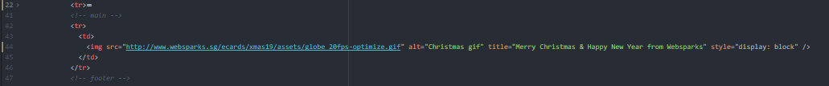

Apart from that, you might want to change the background colour for some of the table cells which all can be found inline.  
The EDM file uses the card image file, Websparks logo, and the fa-socials.png files in the assets folder.

2. Website (index.html)

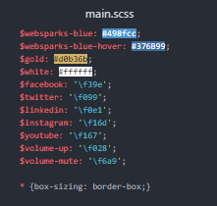This file uses main.css, main.js, the fa-fonts, favicon, and for the card - the image and sound files. Main.css can be amended using the main.scss using sass compiler.

* Typically, there is nothing to change for the js file.
* For the css, you main change the colour themes using the sass file. Simply replace the colours here.
* Replace the music source at line 14 in the <audio> tag
* Replace the image at line 39 in the <img> tag
* The <img> tag is tied to a <map> object. You can change the map coordinates to direct to a clickable area or opt not to use it. Typically, the map is used to create a clickable area for the Websparks logo on the image to direct users to the Websparks main page.
* New images and music can be put in the assets folder